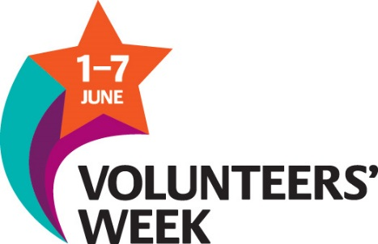

Mill Hill Community Centre – Monday Afternoon Mens Group
Mill Hill Community Centre are re-launching their once popular Mens Activities Group. Every Monday afternoon, local Men are invited to the centre to take part in Social activities where they can meet old and new friends alike. Not everyone is comfortable going to the traditional “Mens” spaces like the Working Mens Clubs or Pubs. Mill Hill Community Centre hopes to provide an alternative place to meet up.
The Centre hopes to recruit volunteers to help this group grow by providing different ideas on activities that these men can try. It might be baking bread, making picture frames, photography…the list could be endless.
If you feel you could help Mill Hill Community Centre and its Mens Group, please come along to their launch on Monday, 5th June at the centre on New Chapel Street Mill Hill between 1pm and 3pm
Anyone needing further information, please call either Fred at Mill Hill on 01254 673066 or Geoff at Community CVS on 01254 583957

Darwen Valley Community Centre – FoodShare Initiative

Darwen Valley Community Centre needs volunteers to help re-launch their FoodShare Scheme – an initiative that helps low income families in Darwen’s more economically deprived areas. Volunteers are needed not only to help collect the food but to also see if the recipients need any other assistance – they may need help with housing, bills, benefits etc…the idea is that the Centre Volunteers would be able to steer Residents towards the right people and organisations that could help them further.
The FoodShare Initiative is planned on Thursday, 1st June from 12pm – 2pm. At Darwen Valley Community Centre on Sudellside Street
If you feel you could help, please call Mark Westall at the centre on 01254 760270 or Geoff Wilkinson at Community CVS on 01254 583957

Accrington Road Community Centre – Indoor Sports Initiative
Accrington Road Community Centre is launching their Indoor Sports Activities and need volunteers to help either coach or run a team/inter centre league that will promote social inclusion.
Accrington Road is keen for young adults in the Intack/Whitebirk/Shadsworth area to come along and use the Community Centre. Downstairs, they have a games room with 3 pool tables but hardly anyone comes to use it. The Centre are keen to attract a group of people who might want to organise their own afternoon pool league – maybe even form their own team to play against other Community Centres.
The Centre already hosts table tennis sessions on a Tuesday afternoon but they are looking for more people to join them as well as someone who might be able to help them become better players.
If anyone would like to join in or could offer their services to help organise coaching and/or competition, please call either Kay at Accrington Road Community Centre on 01254 56120 or Geoff Wilkinson at Community CVS on 01254 583957

Ivy Street Community Centre
Ivy Street Community Centre need volunteers to help run their centre. As a Community Hub, they have lots of activities on offer but they need volunteers to help with…
- General activities involved with running a busy centre
- Help out with existing groups and activities at the centre (eg Arts and Crafts, After school clubs, parties and one off events)
- Develop and attract more activities to the centre
If you feel you have something to offer the centre, please call the centre’s volunteer manager, Darren, on 01254 55977 or Geoff Wilkinson on 01254 583957 for further information

