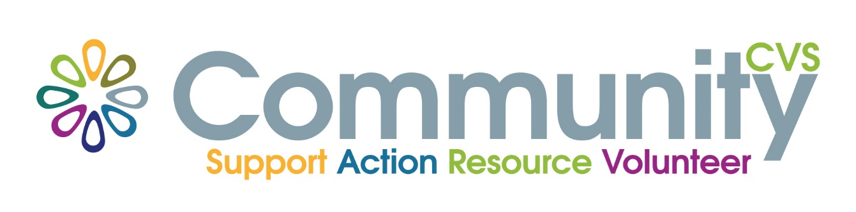
Volunteer Passport
Free Training for Volunteers

Mentoring & Befriending
Wednesday 24t^{h} February 9am – 12.30pm
Mill Hill Community Centre
New Chapel Road, Blackburn BB2 4DT
At the end of the session you will have:
- Defined the meaning of ‘mentor’ difference between mentoring and befriending
. Explored the role of a mentor
•Identified the client’s needs and the expected outcomes from mentoring
•Shared ways of starting & maintaining the relationship and setting boundaries
•Developed strategies for dealing with any difficulties
•Practised goal setting and action planning techniques

For More Information please contact:
Marselle Davies
Tel: 01254 583957
Email: Marselle.davies@communitycvs.org.uk

