Volunteer Passport
Free training for volunteers
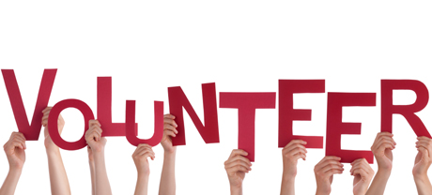
Introduction to Volunteering
Monday 7th March 9am – 12.30pm
Mill Hill Community Centre
New Chapel Road, Blackburn BB2 4DT
At the end of the session you will have:
- Discussed what is Volunteering & why do people volunteer?
• Explored the range of Roles Volunteers & Organisations that recruit volunteers (A-Z guide) & Local Opportunities
• Discussed why do organisations use volunteers and what skills are they looking for
• Explored the benefits of Volunteering & barriers to Volunteering
• Explored what volunteers want and can expect from Volunteering
• Discussed online volunteering
• Introduced the Volunteer Passport File

For More Information please contact:
Marselle Davies
Tel: 01254 583957
Email: Marselle.davies@communitycvs.org.uk

