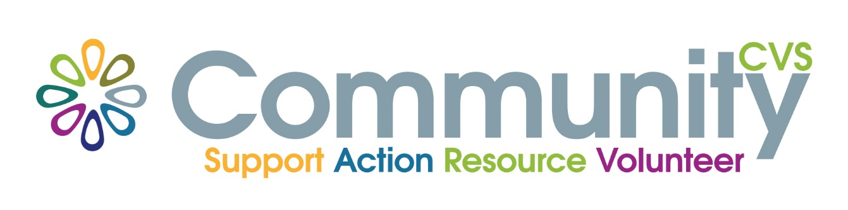
Volunteer Passport
Free training for Volunteers
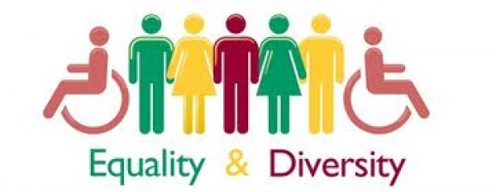
Wednesday 2nd March 9am – 12.30pm
Mill Hill Community Centre
New Chapel Road, Blackburn BB2 4DT
At the end of the session you will have:
- info about Equal Opportunities & Diversity Legislation
•Considered what groups may generally be excluded from their own & other organisations
•Explored how organisations exclude
•Identified how an organisation could change to be more open to different groups of volunteers and service users
•Discussed the benefits of being more open to different groups

For More Information please contact:
Marselle Davies
Tel: 01254 583957
Email: Marselle.davies@communitycvs.org.uk

