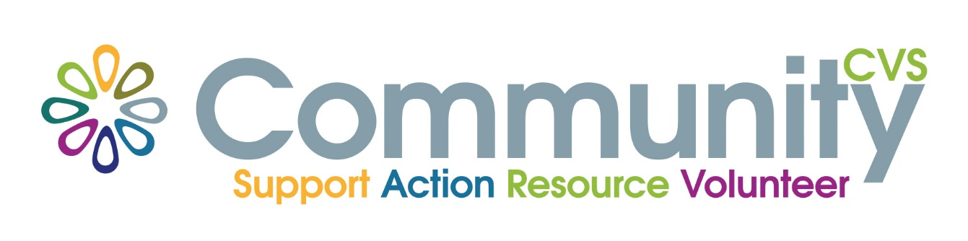
Volunteer Passport
Employability
Wednesday 23rd March 9am – 12.30pm
Mill Hill Community Centre
New Chapel Road, Blackburn BB2 4DT
At the end of the session you will have:
- Looked at matching personal skills & talents to job/voluntary roles
- Discussed making the most of volunteering on CV’s or applications
• Discussed reflective learning
• Identified transferrable skills
• Improve confidence in interviews
• Discussed going forward – Action Planning

For More Information please contact:
Marselle Davies
Tel: 01254 583957
Email: Marselle.davies@communitycvs.org.uk

