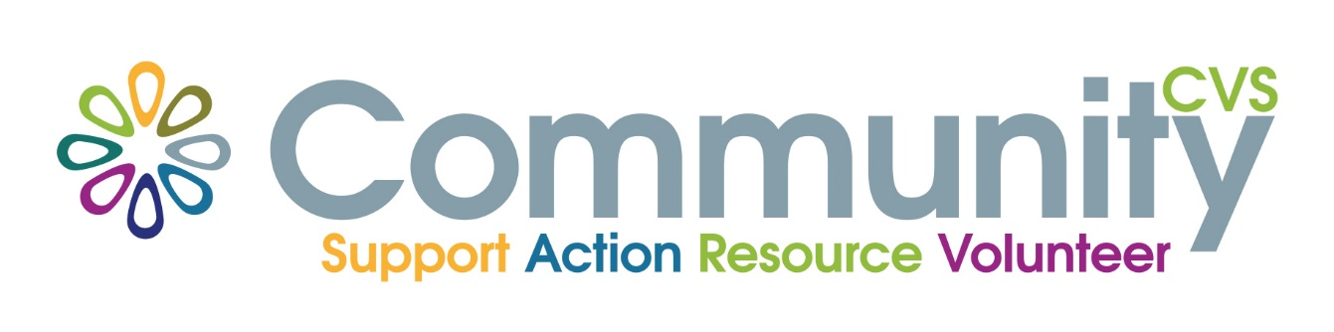
Volunteer Passport
Free training for volunteers
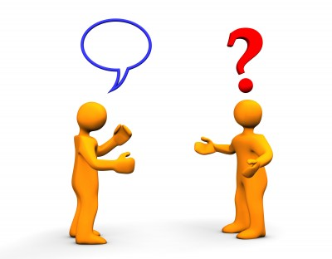
Communication
Wednesday 17th February 9am – 12.30pm
Mill Hill Community Centre
New Chapel Road, Blackburn BB2 4DT
At the end of the session you will have:
- Discussed who volunteers need to communicate with and why
• Explored misunderstandings and why they happen.
• Considered the role of listening in communication.
• Identified different ways of communicating.
• Discussed what to do if things go wrong.

For More Information please contact:
Marselle Davies
Tel: 01254 583957
Email: Marselle.davies@communitycvs.org.uk

