Shadsworth with Whitebirk Big Local
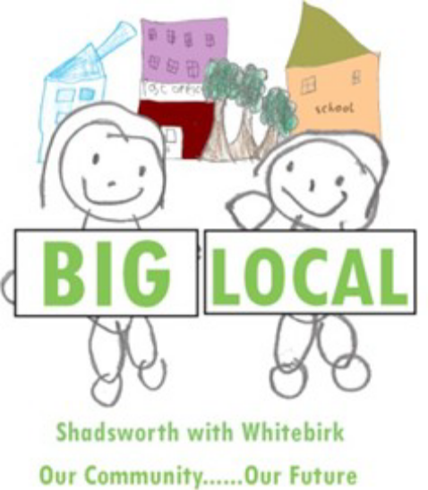
Application Form for the 2015/2016 Small Grants up to £1000

The Small Grants Programme is being run by Community CVS on behalf of the Shadsworth with Whitebirk Big Local Partnership. The fund is a part of the £1million Big Local Ten Year Programme for Shadsworth with Whitebirk.

- The fund is open to ward residents and local charities, social enterprises, voluntary or community groups (i.e. not for profit organisations) and the activity must benefit residents of Shadsworth with Whitebirk
- The group must not directly employ any paid members of staff.
- The group must be run by volunteers and use volunteers to deliver its activities.

If residents have a good idea for a project but are not part of a community group, you can still submit an application. The panel will ask a local community group to hold the grant on your behalf and the community group will be responsible for ensuring the money is accounted for appropriately and project reports are submitted to Community CVS.

The criteria and weight we will use to assess your application will be:-
- Meeting the Big Local’s six objectives & Community Impact for your project (50%)
- Value for Money (25%)
- Involving volunteers & local residents to deliver your project (25%)
Shadsworth with Whitebirk Big Local Trust Board’s six objectives are:-

Objective One: Building Stronger Communities. | Objective Two: Reducing Crime and Anti-Social Behaviour
Objective Three: Improving Money Management. | Objective Four: Building Pride in the Environment
Objective Five: Better Education for Everyone and Getting Jobs. | Objective Six: Living Healthier 4 Longer

Preference will be given to projects that require grant contributions smaller than £1000 which will enable the Board to fund more community groups.

Groups may apply for funding to:
- do a volunteer led activity that makes a difference within your community (e.g. community clean up).
- organise a fundraising event, run a youth club, arts/sports activity, social activity for older people, etc.
- to use volunteers to deliver a community event that brings your community together and builds a better community spirit.
- to set up a new community group that meets an identified local need.
- to support the group’s activities to support residents in Shadsworth with Whitebirk

This list is not exhaustive or exclusive – it is just to try and get you thinking about what you may want to apply for. If you have any questions or queries regarding completing this form please contact Mohammed Kathrada from Community CVS on 01254 583957 / 07883 032786 or email Mohammed.Kathrada@communitycvs.org.uk.

The deadlines for submitting applications are set for 5pm on the last Wednesday of every month.

Completed applications must be e-mailed to Mohammed.Kathrada@communitycvs.org.uk or posted / handed in to Community CVS, Boulevard Centre, 45 Railway Road, BLACKBURN BB1 1EZ (next to the train station). Late applications will not be accepted. All applications will be notified of the outcome within fourteen days of the relevant deadline and can start to spend the grant only after they have received formal approval and have signed and returned a Grant Agreement with Community CVS.

Section One:- About Your Community Group or Organisation
The information provided in paragraphs 1.3 and 1.4 will be used to promote the work of your group to others.

If you are completing the form as a resident with a good idea for a project please

tick this box and complete 1.3 (Main contact) before going on to Section Two:

1.1. Name of group/organisation

1.2. Full address of organisation (for correspondence)

Postcode:

1.3. Main contact
Contact name:
Title:
Position in organisation:
Telephone number:
Email:
Website:

1.4. Brief Description of Your Group/Organisation’s Aims. What are you set up to do?

1.5. Bank account details

1.5 Please provide you organisations Bank Details,
Please Note: If you do not have a Bank Account then please provide Bank Details of a supporting organisation who is willing to hold funds on your behalf.

Account name as it appears on cheque book:
Bank/Building Society:
Bank/Building Society Address:
Sort code:
Account number:
Confirmation that your account requires two signatories for all payments

Section Two:- About Your Project
2.1 What is your project?
What activity do you plan to deliver? Where will it take place and who will benefit?

2.2 Meeting the Big Local’s Objectives & having a Community Impact
How does your project support one or more of Big Local’s six objectives and what community impact will it have?

2.3 How will your project represent value for money?
How many volunteers or residents will benefit from your project for the amount of grant you require? Will anybody else be contributing funds to the project?

2.4 Involvement & Benefits for Volunteers & Local Residents
How will your project involve volunteers and local residents? How will they benefit? How many volunteers will be involved? What will they be doing? How many estimated hours will they be involved?

Section Three:- Project Details and Financial Information

3.1. Will your project be working with children and/or vulnerable adults?

3.2. Start date for this project End date

Please note, an end of project report will be needed. We will need this within one month of the project end date. This can be brief, and ideally should include pictures. More information will be provided if you are successful with your bid.

3.3 Where will the project/activity take place? Which parts of Shadsworth with Whitebirk will be covered?
Please name the neighbourhood or venue where your project will be delivered (including the name of the venue, street name, town and postcode).

3.4 Project Outputs

Output | Insert a Number
How many volunteers are involved in your group?

How many volunteers will help to deliver this project?

How many total volunteers hours will you use to deliver the project?
[number of volunteers x average amount of time involved with the project]
How many residents of Shadsworth with Whitebirk will participate or benefit from the project?
How many people from outside of Shadsworth with Whitebirk may participate or benefit from the project?

3.5 Project budget

Type of cost | Description | Total Cost + VAT
Total
Total grant requested

3.6. If the total cost of your project is higher than the amount being requested, please tell us how the remainder will be funded and whether this funding is already in place?

3.7. We would greatly appreciate your help in making Big Local Shadsworth and Whitebirk more well known. We want more grant requests from the community. If your application was successful, how will you promote that the project was funded through Big Local?

Section Four:- Authorised Signature and Supporting Documentation
Authorised Signature
I am authorised to act on behalf of the group / organisation in submitting this application.

I have read and accepted the conditions of CVS membership on behalf of the group / organisation and confirm our written consent to becoming a CVS member. If you do not wish to become a CVS member please tick the relevant box below.

I have enclosed the necessary documentation.

I understand and accept that our organisational contact details will be held by Community CVS in electronic and paper format and be used to contact our group / organisation in the future.

I understand that information provided within this application may be used to publicise the work of your group / organisation. If you do not wish for Community CVS to promote your group / organisation – please tick the relevant box below.

Position in organisation | Name (printed) | Signature

Community CVS Membership & Big Local Publicity
We will automatically make your group a member of Community CVS (if you qualify and are not already a member). Community CVS & Big Local will actively promote the work of your group / organisation. If you do not want either of these please tick the relevant box below:-

Our organisation does not want to be a member of CVS

Our organisation does not want CVS or Big Local to promote our work

Supporting Documentation Checklist (if you are a community group/charity)
The following supporting information/documents are required and must accompany your application.

Checklist of Required Supporting Documentation (if available) | Please Tick ()
A copy of your group’s constitution, governing document or set of rules.
A list of names, addresses and relevant e-mail contacts (if applicable) of who is on your management committee
A copy of your group’s most recent accounts/financial statements/report (if available)
A copy of the group’s bank statement (within the last 3 months)

